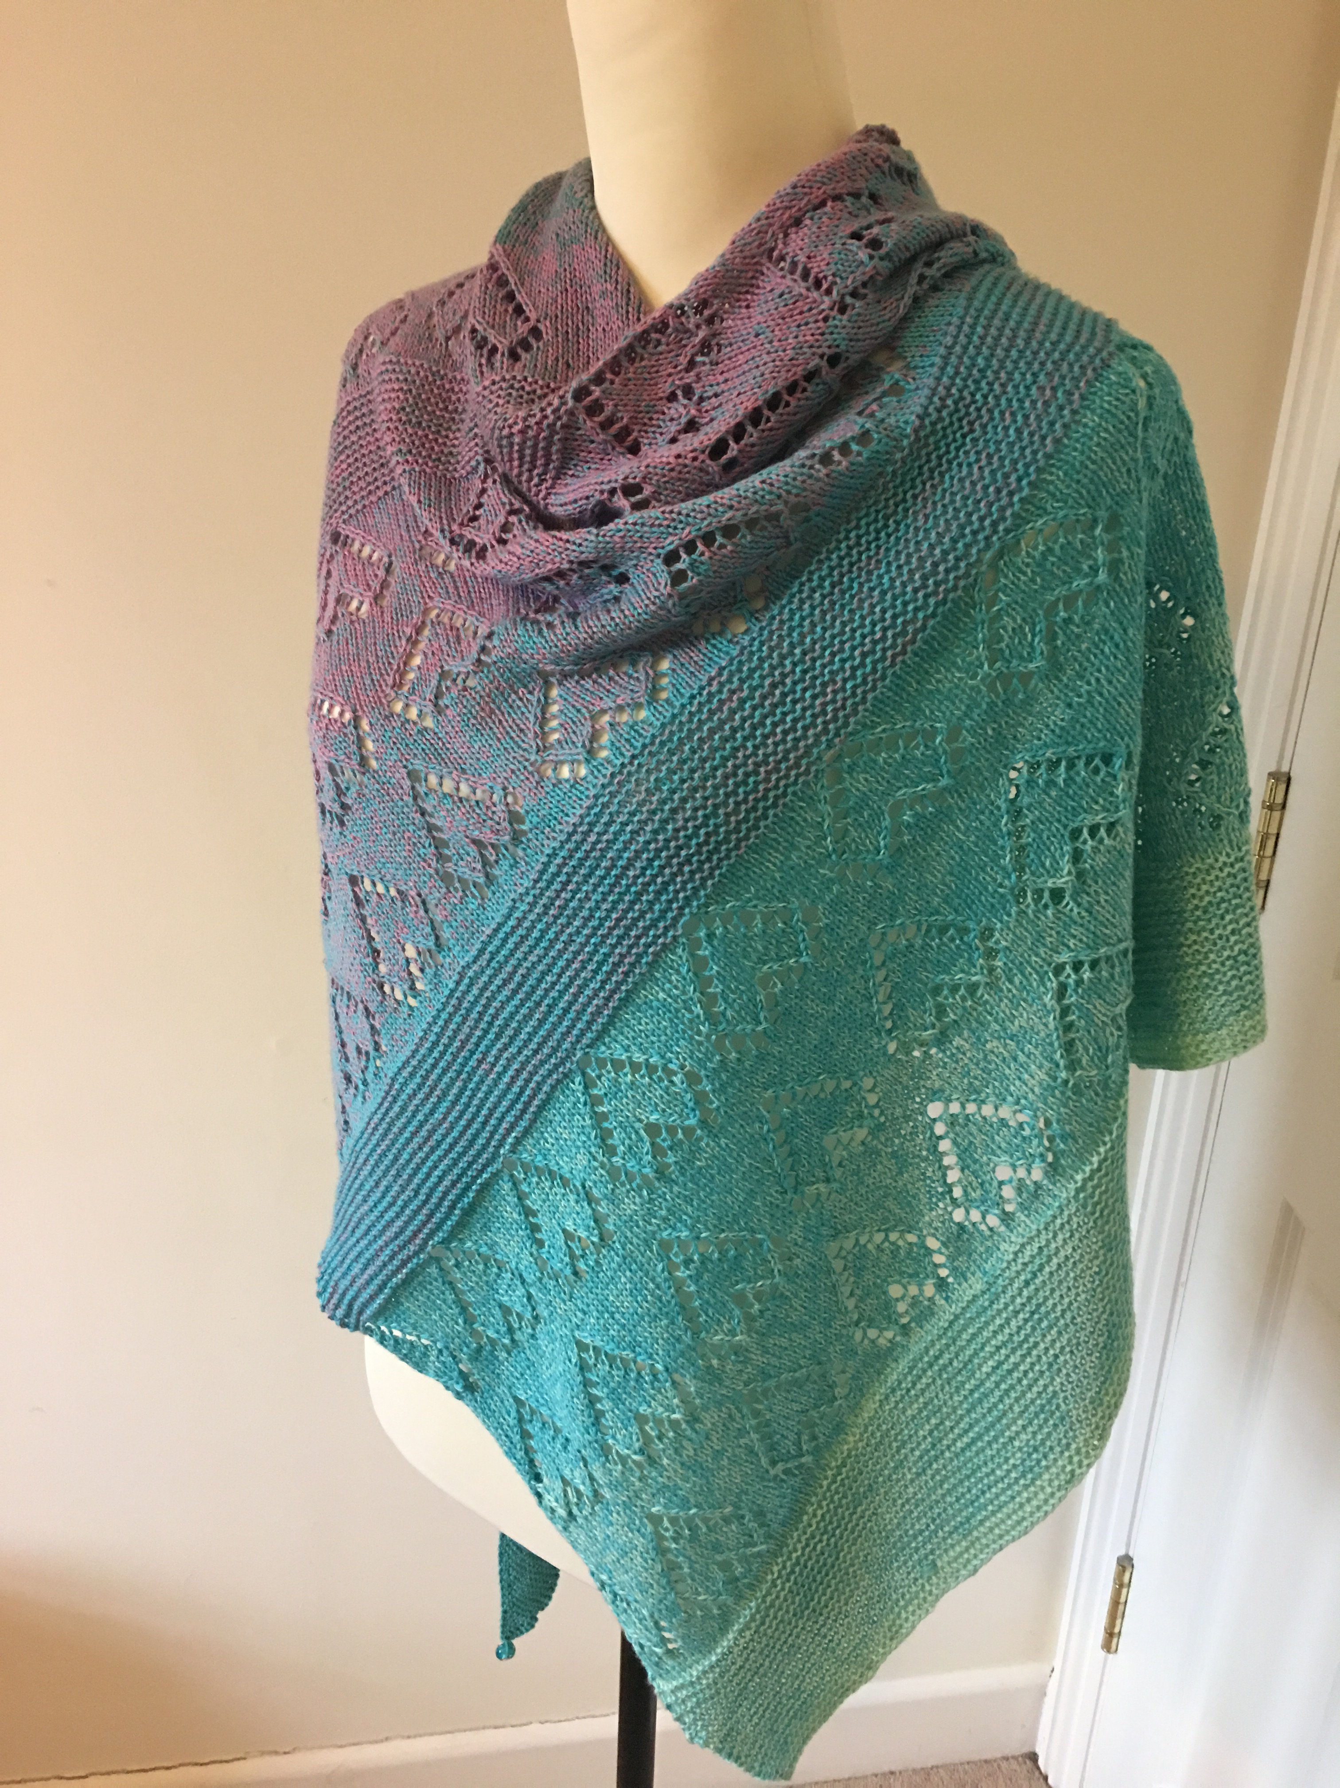
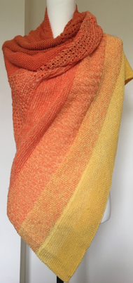
Instruction for the Yarn Mixology Shawl.
This shawl is designed to show off the gorgeous colours of your Yarn Mixology bobble. By mixing up the easy patterns and stitches every time you encounter one of the tiny knots where the yarn changes, you’ll create a soft ‘brushstroke’ effect. Recommended needle size is 3.25mm. The shape is an asymmetrical triangle, with increases on only one side of the shawl. Make it big enough to fit snug around your neck or, like me, create a huge shawl that can be worn in many ways. Then get used to people asking you where you bought this delicious piece of cover up!
Read through the easy instructions and use them either as a guide, or simply as inspiration for your own creation. For a neat, flat edge, I recommend that you slip the first stitch of each row knitwise. To give your patterns a neat frame, it’s also nice to knit the first and last 3 stitches of each row simply in garter stitch, then carry on with your pattern or, if you are opting for a garter stitch shawl, just carry on knitting. If you are not quite sure that you are on the right track, take a look in the Photos section of our Yarn Mixology Shawl group on Facebook, where you will find snapshots of each stage. Need more guidance? Post in the group or message me – I’m always happy to help.
Note: The increases are ALWAYS on just ONE side of the shawl – at the beginning of each WS. That way, you can concentrate on working your lovely patterns on the RS row without distraction!
Cast on 3 stitches
1st row (RS) – knit 3
2nd row (WS) – slip the 1st stitch knitwise, increase 1 by knitting into the front and back of the next stitch, knit 1
3rd row (RS) – slip the 1st stitch knitwise, knit 3
4th row (WS) – slip the 1st stitch knitwise, knit into the front and back of the next stitch, knit 2
5th row (RS) – slip the 1st stitch knitwise, knit 4
6th row (WS) – slip the 1st stitch knitwise, knit into the front and back of the next stitch, knit 3
7th row (RS) – slip the 1st stitch knitwise, knit 5.
After only 7 rows you now have a tiny triangle. Look closer and you’ll see that one side is straight, while the other side is getting wider – this is the start of your asymetrical triangle. You will, from now on, increase (by knitting into the front and back of the stitch) at the BEGINNING OF EACH WS only. So, slip the 1st stitch knitwise, work your increase, knit 1.
Repeat rows 6 + 7 until you get to the first tiny knot (about 80 stitches will be on your needle now)
Now let’s look at patterns. Knit in simple garter stitch (each row is just knit – no purls at this stage) until you get to the first tiny knot. Your triangle will be about 20cm high and the colour will now change gently. Time to switch patterns! Knit to the end of your next WS row and turn – you now have your ‘slopey’ end (where you’ve been increasing) on your left.
Simple Stripes
Row 1 (RS) – Slip the 1st stitch knitwise, knit to the end
Row 2 (WS) - Slip the 1st stitch knitwise, increase 1 by knitting into the front and back of the next stitch, knit 1, purl until the last 3 stitches, knit 3
Row 3 - Slip the 1st stitch knitwise, , knit to end
Row 4 - Slip the 1st stitch knitwise, increase 1, knit 1, purl until the last 3 stitches, knit 3
Row 5 – repeat row 3
Row 6 – repeat row 4
Row 7 - Slip the 1st stitch knitwise, knit 2, purl until the last 3 stitches, knit 3
Row 8 – Slip the first stitch knitwise, increase 1, knit to the end
REPEAT ROWS 1 – 8 until you get to your next little knot and the colour changes again.
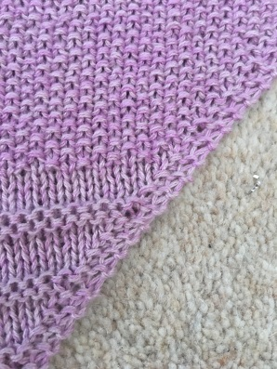
YOU ARE NOW IN THE SWING OF THINGS! DON’T FORGET TO
SLIP THE FIRST STITCH OF EACH ROW KNITWISE AND KNIT
THE FIRST AND LAST 3 STITCHES OF EACH ROW IN GARTER STITCH
FOR YOUR NEAT, FLAT EDGE. ON EACH WS ROW
(WHERE YOUR INCREASE EDGE IS ON YOUR RIGHT) DON’T
FORGET YOUR INCREASE
Seed stitch
Row 1: k1, * p1, k1; rep from *
Row 2: repeat
Repeat until the next tiny knot indicates a new colour change. Finish the row, then start the next pattern on a RS row
Simple lace
Row 1: *k3, yo, k two together* rep from *
Row 2: knit all stitches, including the yo’s
Repeat rows 1 and 2 until the next colour change
I suggest that you simply repeat the patterns for your next stripes. Or mix it up and experiment with your favourite simple stitch patterns. The sky (or the shawl!!!) is the limit.
Become a member of our Facebook group Yarn Mixology Shawls to see more pattern suggestions, projects and colour combos. You will also find step by step pictures and
video clips to help you along if needed. And don’t forget to share your finished shawl with us!

Rice stitch
Row 1 (RS): p1, *k1 tbl, p1; rep from *
Row 2: k
Moss stitch
Any odd number
Rows 1 and 4: *k1, p1; rep from *, end k1
Rows 2 and 3: *p1, k1; rep from *, end p1
Any even number
Rows 1 and 2: *k1, p1; rep from *
Rows 3 and 4: *p1, k1; rep from *
Little Pyramids
Row 1: k5, *p1, k5; rep from *
Row 2: k1, *p3, k3; rep from *, end p3, k1
Row 3: p2, *k1, p5; rep from *, end k1, p2
Row 4: Rep Row 3
Row 5: Rep Row 2
Row 6: Rep Row 1
Garter Lace
Rows 1-6: k
Rows 7 and 9: k1, *yo, k2tog; rep from *, end k1
Rows 8 and 10: k1, *yo, p2tog; rep from *, end k1
Garter Eyelet
Rows 1 through 4: k
Row 5: *k2tog, yo* - rep from *, end k1
Row 6: k
Rose stitch
Very simple and easy to remember repeats. It provides nice texture with strong diagonal lines.
It's not as difficult as it seems to knit in the stitch in the row below. Literally insert your needle into the center of the st in the row below the next st on the left needle, then knit as normal. You do not knit the next st on the left needle; when you complete the st in the row below instead, it is simply removed when completed. Try it!
Multiple of 2 + 1
Row 1: k2, *p1, k1; rep from *, end k1
Row 2 (RS): k1, *k1 in st in row below, k1; rep from *
Row 3: k1, *p1, k1; rep from *
Row 4: k2, *k1 in st in row below, k1; rep from *, end k1

